Name:-Keya Jadhav
PRN:-123B1B142
File:-
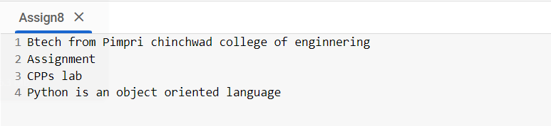
CODE:-
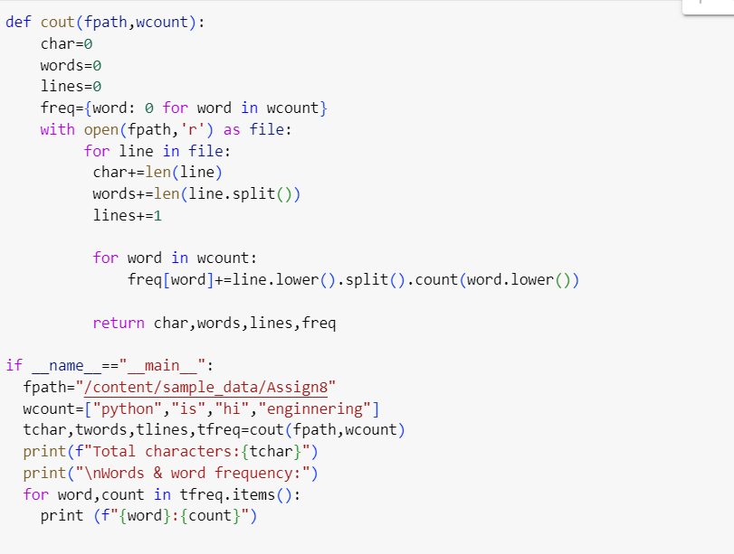
OUTPUT:-s
